An early step in many types of biological studies is locating and accessing populations of the focal organism to sample. Often, this is as simple as examining occurrence records from natural history collections and non-voucher-based observations in online data aggregators such as the Global Biodiversity Information Facility (GBIF; [www.gbif.org](http://www.gbif.org)). Smaller regional data aggregators can be helpful too (e.g., <http://swbiodiversity.org/seinet/>). Here’s an example of the species occurrence page for a common mid-elevation forest tree, ponderosa pine (*Pinus ponderosa*, Pinaceae), from GBIF (<https://www.gbif.org/species/5285053>). Here’s the specimen occurrence map from that page, zoomed to western North America, with a few modifications to show actual collection points:



Unlike ponderosa pine, some plants are adapted to much narrower ecological settings. In the California flora, world-renowned as a biodiversity hotspot, many plants occur on just one soil type (e.g., serpentine or limestone), just one mountain range, or just one island. Here’s an example of a few of these narrow “endemic” plant species:

Fountain thistle (*Cirsium fontinale* var. *fontinale*; Asteraceae), an endemic to serpentine soil:

<https://www.gbif.org/species/7066663>

Map (showing San Francisco Bay region):



Refugio manzanita (*Arctostaphylos refugioensis*; Ericaceae), an endemic to the Santa Ynez Mountain range:

<https://www.gbif.org/species/2882555>

Map (showing Santa Barbara region and northern Channel Islands):



Catalina ironwood (*Lyonothamnus floribundus* subsp. *floribundus*; Rosaceae), an endemic to Santa Catalina Island:

<https://www.gbif.org/species/3027434>

Map (showing southern California and the Channel Islands):



In the above cases, despite narrow distributions, biologists who wish to study these plants would use online databases to locate occurrences to sample, obtain proper permits, and then travel to accessible populations to conduct the field work.

Some narrowly distributed plants, however, are not easy to sample by biologists. Some plants have a life history strategy that includes avoiding competition by “escaping” onto vertical cliffs, or even more narrowly, on off-shore rocky islets surrounded by cliffs. Some of these locations may be traversed by biologists with technical rock climbing experience, but only a subset of these types of locations have suitable anchoring locations. Therefore, many locations cannot be sampled without mastery of a risky discipline, and some not at all.

At the Santa Barbara Botanic Garden, plant evolutionary biologists are studying two groups that specialize on cliffs or that occur on off-shore islets. The first group of plants is known as the live-forevers (*Dudleya*; Crassulaceae). Many of the 40 or so species of *Dudleya* live on vertical cliffs, including several that are listed by the Federal government as Endangered or Threatened. Interest in better understanding these plants is intense, especially on the part of government agencies such as the National Park Service, yet sampling the core distributions of each of these high on cliffs has not been possible. Here is an example of a rare *Dudleya*, *D. parva*, that occurs on volcanic cliffs:

Live-forever (*Dudleya parva*), endemic to Conejo volcanic cliffs near the city of Moorpark:

<https://www.gbif.org/species/4198191>

Map:



Image showing cliffs where *D. parva* occurs, some plants are accessible to Garden Conservation Geneticist Dr. Kristen Lehman, but most plants are not:

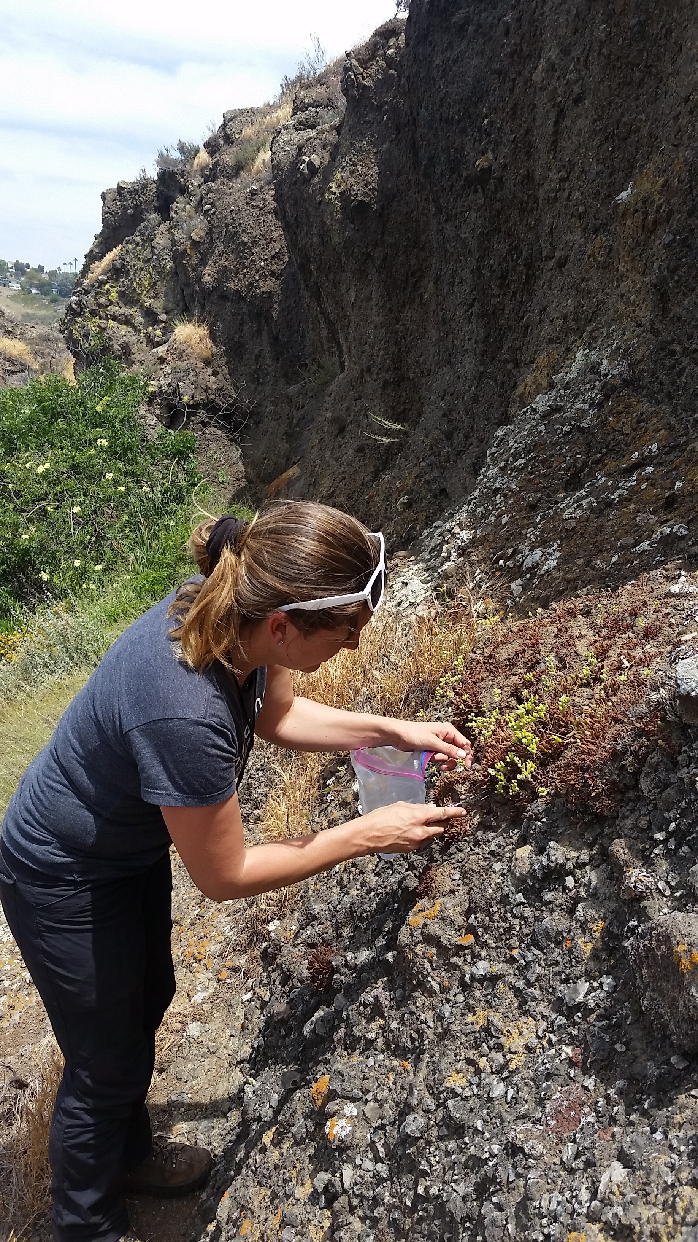

The Garden is also studying the species called island mallow (*Malva assurgentiflora*; Malvaceae), which is a California Channel Islands endemic known to be naturally occurring on only four of the eight islands. On each of these four islands where the species grows, it has been severely impacted by feral animals introduced deliberately by people for hunting and/or food production. In some cases, such as on Santa Catalina Island, these plants were formerly known from many locations on each island, but they have been locally extirpated and now grow only on tiny off-shore rocks. While these rocks can be visited by zodiac or kayak, some such as Indian Rock, are risky to climb.

Island mallow (*Malva assurgentiflora*), endemic to the Channel Islands:

<https://www.gbif.org/species/3935047> (note that the map shows many occurrences that represent cultivated plants)

Map of Catalina locations (showing northern coastline of Catalina island; land is white, ocean is gray):



Image showing Indian Rock, an off-shore rocky islet that supports one of two populations of *Malva* on Catalina Island:

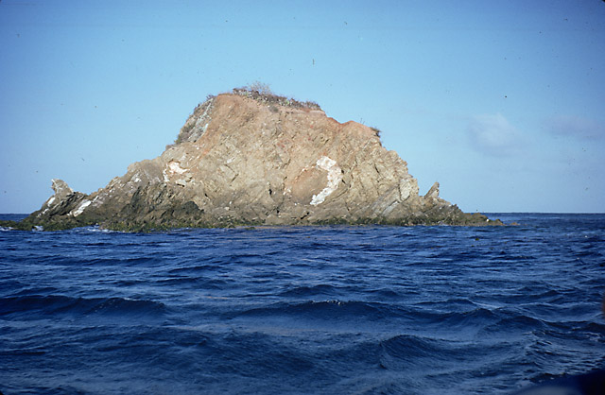

Drone technology can potentially be used to survey and sample plants such as *Dudleya*, *Malva*, and others that would otherwise be difficult or impossible to access. From the perspective of the biologist, an ideal build would include the following features:

1. Rugged design, field-deployable

2. Reasonable battery life

3. Ability to pilot using ruggedized laptop or (better) tablet

4. Ability to take image data of horizontal surfaces (tops of islets) and vertical surfaces (cliff faces)

5. Ability to precision cut and retain samples of plants of different shapes and sizes